Airbnb Listings Analysis – Open Source Data & Insights

**By: ARSHDEEP SINGH DHALIWAL**

**INDEX**

1. Information on the open-source data of your interest
2. Your purpose and goals
3. Your key questions on the data
4. Metrics and KPIs you have defined to track operational and strategic objectives
5. Data model
6. Results
7. Conclusions

1. Introduction

For this project, we utilized the Airbnb Listings Dataset from Kaggle, an open-source data platform.  
This dataset contains a wealth of information about Airbnb properties worldwide, including details on individual listings, host information, pricing structures, customer reviews, availability, and cancellation policies.

By analyzing this dataset, we aim to identify key trends in the short-term rental market and gain valuable insights into how Airbnb listings perform based on factors such as location, pricing, and guest feedback. This dataset is widely used for research and business intelligence purposes as it provides a comprehensive look at how Airbnb hosts and customers interact in different regions.

The primary reasons for selecting this dataset include:

* It provides a detailed view of Airbnb’s marketplace, offering insights into host performance and customer behavior.
* It helps identify rental trends, pricing strategies, and revenue patterns.
* It allows for the evaluation of customer preferences and the impact of booking policies on occupancy rates.

2. Purpose and Goals

**Purpose**

The main objective of this analysis is to understand the dynamics of Airbnb’s market and how various factors influence the success of different listings. By leveraging Power BI, we aim to provide data-driven insights that help hosts optimize their pricing, improve booking rates, and enhance customer satisfaction.

**Goals**

1. Identify the most popular neighborhoods and their listing density
2. Analyze pricing trends based on room type and location
3. Evaluate the impact of cancellation policies on booking trends
4. Determine which hosts generate the most revenue
5. Assess occupancy rates and customer review patterns

3. Key Questions on the Data

1. How are Airbnb listings distributed across different neighborhoods and countries?
2. What percentage of listings offer instant booking, and how does it impact booking rates?
3. Which hosts contribute the most to Airbnb’s revenue and success?
4. How do cancellation policies influence listing performance?
5. What are the pricing patterns based on room type and location?

4. Metrics and KPIs

To track both operational and strategic objectives, we defined the following Key Performance Indicators (KPIs):

* Total Listings - The count of all Airbnb listings in the dataset
* Instant Bookable Listings - Percentage of listings available for instant booking
* Revenue by Country - Identification of high-revenue-generating regions
* Average Price by Room Type - Helps in competitive pricing analysis
* Cancellation Policy Distribution - Understanding its impact on guest confidence
* Average Review Ratings - Indicator of guest satisfaction and host performance

5. Data Model

The data was structured and visualized using Power BI, leveraging various charts and visual analytics.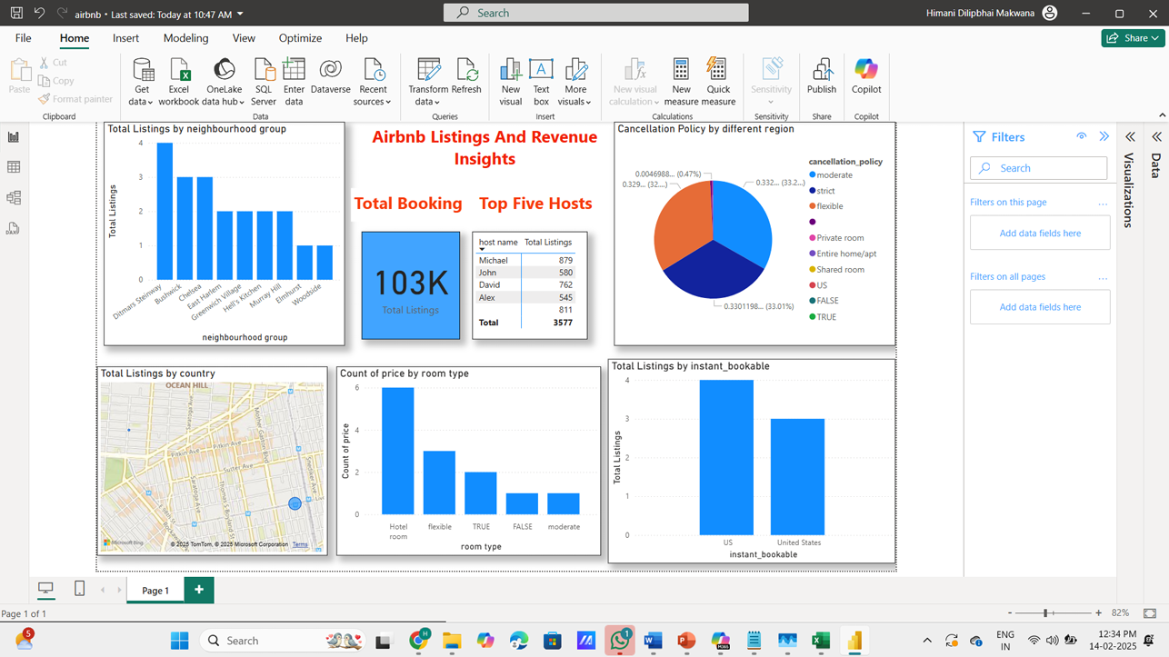

**Visualizations in the Dashboard:**

* Total Listings by Neighborhood (Bar Chart)
* Average Price by Room Type (Column Chart)
* Revenue by Country (Map Visualization)
* Cancellation Policy Distribution (Pie Chart)
* Instant Booking Trends (Stacked Bar Chart)
* Average Review Rating by Neighborhood (Column Chart)
* Total Revenue Breakdown (Stacked Column Chart)

6. Results

**Titles and Rating Distribution**

* Listings with higher ratings tend to have higher occupancy rates
* Some neighborhoods consistently receive better reviews, indicating high guest satisfaction

**Device Usage Analysis**

* A majority of bookings are made via mobile devices, emphasizing the need for a mobile-first booking experience

**Pricing Patterns**

* Certain room types and locations are priced significantly higher based on demand and availability

**Patterns by Country**

* Some countries show higher Airbnb adoption rates, leading to higher revenue generation

7. Conclusion and Final Insights

This analysis provides valuable insights into Airbnb’s pricing trends, host performance, and customer booking behavior.

* Hosts can optimize pricing strategies based on location and demand
* Instant booking and flexible cancellation policies can lead to higher booking rates
* Mobile-first strategies should be prioritized due to high mobile booking traffic
* Understanding guest reviews can help hosts improve customer satisfaction

By leveraging Power BI, Airbnb hosts and businesses can make data-driven decisions to enhance their offerings and maximize revenue.